ENTERPRISE WORKFORCE PRODUCTIVITY AGENT • QUICK-START GUIDE
iHRMS Desktop
Official Employee & Operational Manual | Version 1.0.0 (Windows & macOS)
――――――――――――――――――――――――――――――――――――――――――――――――――――――――――――――――――――――――――
1. Executive Overview & Purpose
iHRMS Desktop is a high-performance cross-platform enterprise client engineered for Windows 10/11 and macOS 11+. It eliminates manual timekeeping by providing automated foreground application focus logging, biometric punch synchronization, real-time leave balance tracking, KRA timesheet submissions, and visual audit compliance. Built with an offline-first architecture, all records and screenshots buffer locally in ACID SQLite during network drops and synchronize seamlessly upon reconnection without data loss.
2. Two-Stage Secure Setup & Authentication
- Stage 1 — Company Code Verification: Enter your corporate tenant code (e.g. INDOVISION, ALPHA). Click 'Verify Company' to resolve dedicated API endpoints, fetch company branding, and lock workspace context.
- Stage 2 — Employee Login & Transparency Consent: Enter Employee ID and Password. Check the required transparency acknowledgement checkbox confirming workplace activity tracking according to corporate policy.
- Cryptographic Device Binding: Click 'Login'. The client authenticates credentials, securely binds the machine's hardware UUID to prevent buddy-logging, and launches the operational dashboard.
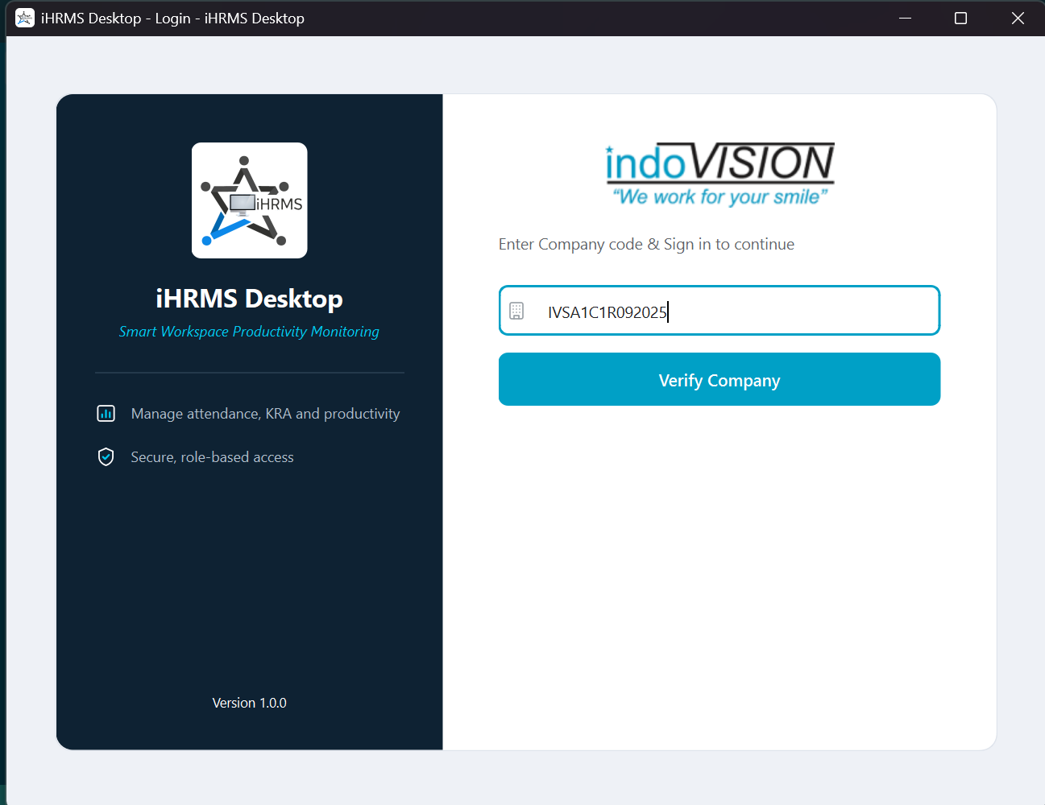 | 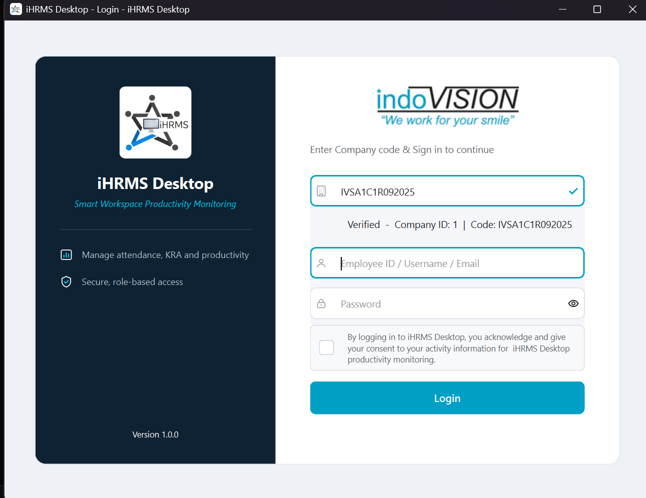
Figure 1.1: Stage 1 — Multi-Tenant Company Code Verification | Figure 1.2: Stage 2 — Credentials, Consent & Device Binding
3. Setup & Authentication Quick Reference
Lifecycle Step | System Behavior | Operational Purpose
Initial Verification | Company Code required once; saved locally in encrypted storage. | Verify company code with HR if verification fails.
Monitoring Transparency | Requires user consent checkbox acknowledging telemetry capture. | Ensures compliance with enterprise privacy standards.
Hardware Scoping | Session bound cryptographically to workstation UUID fingerprint. | Prevents ghost logins and unauthorized machine sharing.

2. Dashboard Command Center & Real-Time Focus loging
The Dashboard is the operational hub for employees, providing instant visibility into active tracking status, biometric attendance punches, cloud synchronization counters, and active foreground application focus.
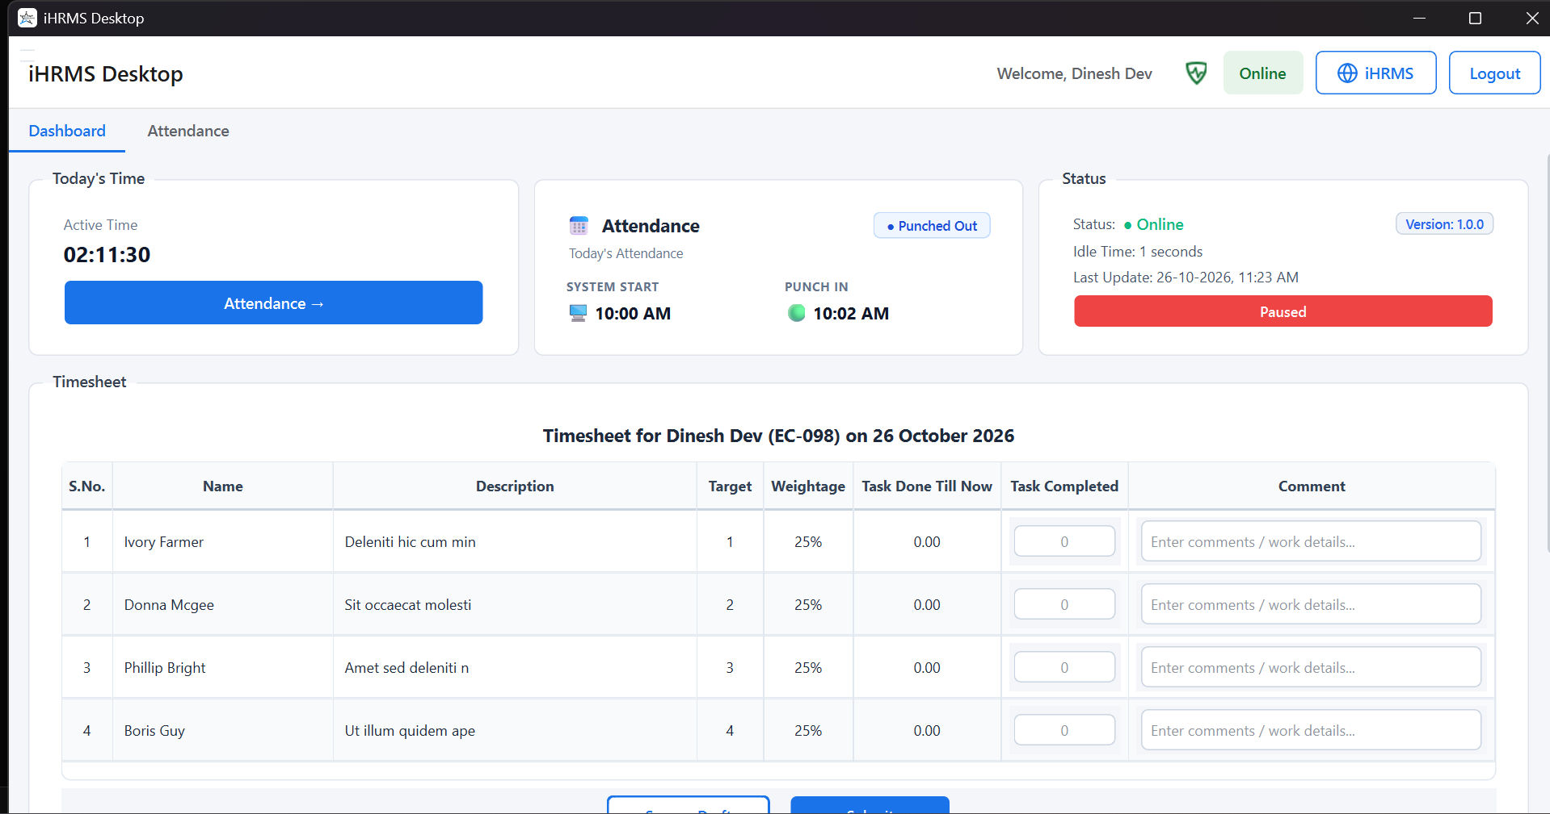
Figure 2.1: iHRMS Desktop Main Dashboard with Real-Time KPI Telemetry Cards & Active Focus
Core Dashboard Telemetry Components
- Header Navigation Bar: Displays employee name, verified company logo, network reachability badge (Online/Offline), WorkPulse status badge, and the 'HRMS Portal' auto-login bridge.
- Active Focus Time Card: Accurately computes cumulative productive focus duration logged across all active applications today (HH:MM:SS), excluding detected idle periods.
- Attendance Punch Status: Displays morning punch-in timestamp (e.g. 09:30 AM) and punch badge (Punched In / Out), synchronized directly from corporate attendance logs.
- Records Uploaded Metric: Shows the total count of telemetry activity batches successfully acknowledged and stored by the cloud backend during the active session.
- Active Window Focus Card: Displays real-time foreground application executable (e.g., chrome.exe, code.exe), window title, and active duration.
Operational Tracking Badges & Indicators
Status Badge | Visual Theme | Operational Meaning & System Action
● work Active | Emerald Green | iHRMS Desktop engine is actively logging window title, PID, and user input focus.
● Punched In | Mint Green | Biometric punch has been validated for today; attendance working time is actively counting.
● Online | Forest Green | Client has verified HTTPS connectivity to corporate APIs; real-time sync is operational.
● Offline | Slate Gray | Network connectivity is interrupted; local SQLite buffer is preserving all records safely.
● Paused / Error | Amber / Red | Tracking is paused by user permission or interrupted; inspect system tray for details.

Workstation Lock (Win + L) & Idle Detection
iHRMS Desktop monitors hardware input timers. If user input ceases beyond the corporate threshold (default: 300s), tracking transitions to idle state. Locking the workstation (Win + L) or display sleep immediately halts focus logging, preventing lock-screen processes (LockApp.exe) from inflating active duration.

3. Activity Logs, Screenshot Engine & Sync Resilience
iHRMS Desktop is engineered for low system overhead (<85 MB RAM, <1% CPU) while guaranteeing tamper-resilient data integrity and automatic cloud synchronization even over unstable network connections.
Activity Collection & Timeline Breakdown
- Continuous 1s Polling: Inspects OS window handle, PID, executable name, and sanitized window title every second, logging exact focus durations.
- Idle Time Attribution: Preserves the active application state upon idle entry and attributes elapsed idle time cleanly upon resumption.
- Display-Off & Lock Screen Guard: Immediately pauses active window tracking during system lock or sleep; resumes seamlessly upon user unlocking.
Visual Audit Screenshot Engine & Storage Optimization
- Periodic Screen Capture: Captures desktop snapshots at policy-configured intervals (e.g. 5–10 mins). Multi-monitor displays are combined automatically.
- Intelligent Quantization: High-efficiency JPEG/PNG compression ensures screen captures average 50–80 KB without straining network bandwidth.
- Server-Confirmed Local File Cleanup: Screenshots stage temporarily in %LOCALAPPDATA%\iHRMSDesktop\screenshots\. Upon server receipt and HTTP 200 confirmation, the local image file is immediately purged to eliminate disk bloat.

Offline Resilience & Batch Synchronization Workflow
Mode | Telemetry Pipeline Action | Storage & Verification Outcome
Online Sync | Batches of 50 closed sessions uploaded every 60–300s via HTTPS POST. | Immediate HTTP 200 receipt; local DB marks records as is_synced=1.
Offline Buffer | Client buffers all sessions, idle logs, and screenshots in local SQLite. | Zero data loss; retry backoff timers activate without freezing UI.
Reconnection | SyncService detects online reachability and flushes backlog chronologically. | Server acknowledges backlog; local screenshots are pruned; counter updates.

4. Attendance, Leave Balance, Timesheets & Guidelines
The client integrates full attendance verification, dynamic leave quota management, daily timesheet fulfillment, and background system tray supervision into a single unified desktop experience.
Attendance Calendar & Dynamic Leave Quotas
- Monthly Calendar Grid: Access via 'Attendance' tab. Displays daily status indicators: Present [P] (Green), Absent [A] (Red), Half Day [HD] (Orange), Week Off [WO] (Blue), Holiday [H] (Cyan), Approved Leave [L] (Amber).
- Attendance Compliance Ring: Monthly progress ring calculates attendance compliance percentage (e.g. 91% Good), working days, and exact biometric punch timestamps (In/Out/Total).
- Dynamic Leave Balance Dialog: Click 'Leave Balance' on Attendance page to inspect real-time leave entitlement quotas (Casual, Privilege, Sick, Comp-Off) showing total, used, and available days.
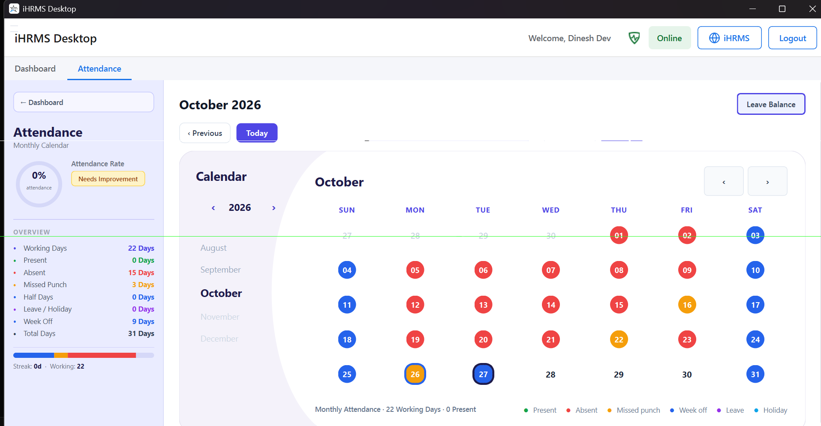 | 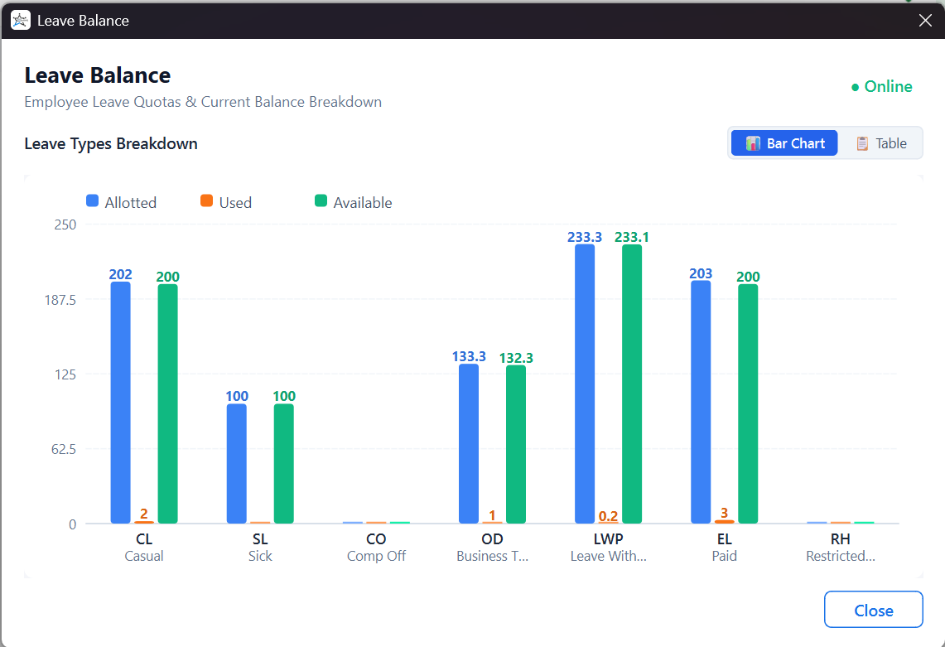
Figure 4.1: Monthly Attendance Calendar & Compliance Ring | Figure 4.2: Dynamic Leave Balance Quota Breakdown
Assigned KRA Timesheets, System Tray & Supervision
- Daily KRA Timesheet Table: Located on dashboard. Employees review assigned tasks, update completion percentage (0–100%), enter accomplishment remarks, and submit for manager review.
- System Tray Minimization: Closing or minimizing docks the app in the Windows Notification Area / macOS Menu Bar with background tracking indicators.
- Transparent Supervisor & Silent Updates: A background monitor (iHRMS-Supervisor.exe) safeguards against unexpected crashes. Authorized updates install silently without user disruption.
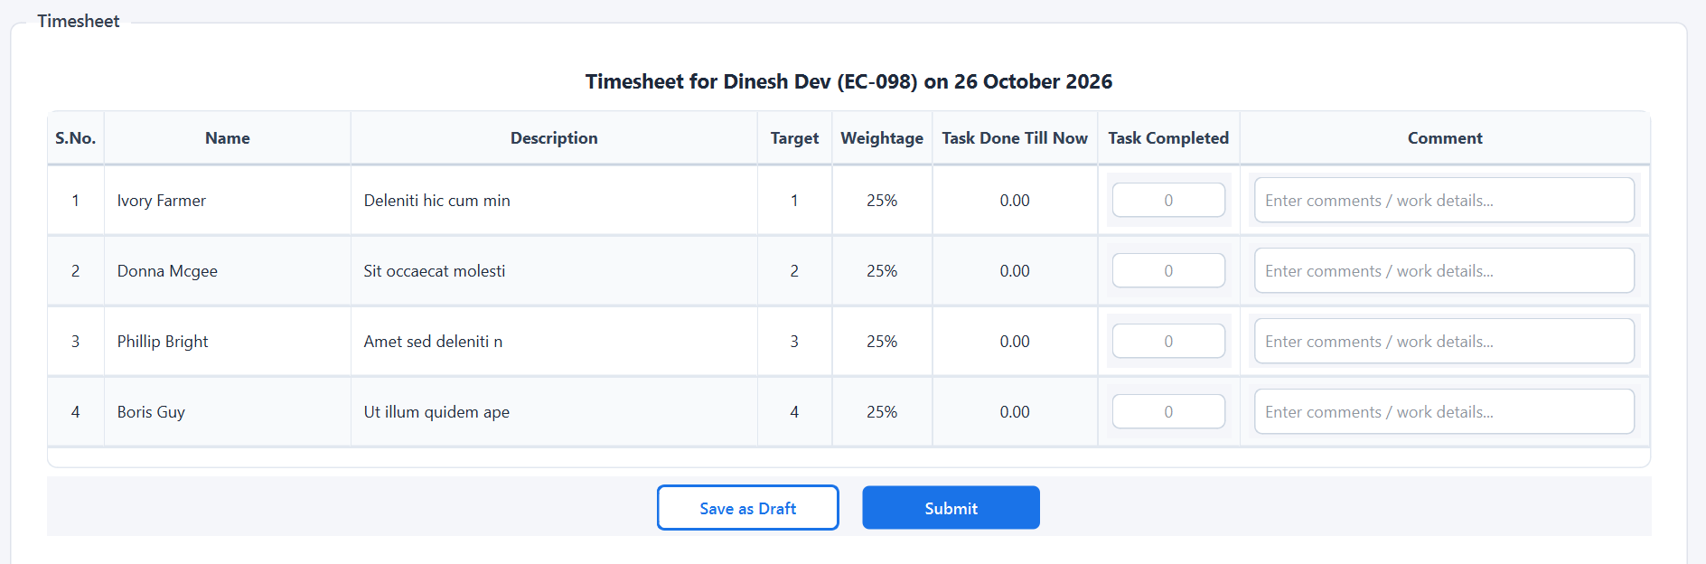
Figure 4.3: Assigned KRA Timesheet & Task Progress Remarks Widget
Operational Standard Operating Procedures (SOP)
Phase | Standard Operating Procedure & Best Practices
Shift Start | Launch iHRMS Desktop; verify green '● Tracking Active' and '● Online' indicators.
Workstation Lock | Press Win + L whenever stepping away; tracking pauses and attributes idle time accurately.
Shift End | Complete KRA task remarks, click 'Submit Timesheet', and ensure records sync before exit.
Support | Contact Indovision Enterprise Support at support@indovisionservices.in for technical assistance.

